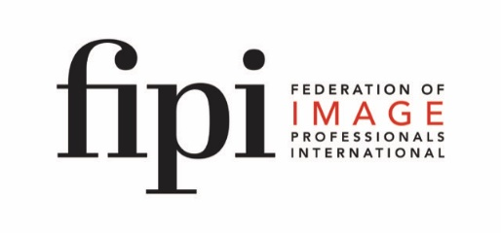

APPLICATION FORM
for FIPI Master Award in International Business Etiquette

Name:

Address:

Telephone:
Mobile:
Email:
Website:

hereby applies for the FIPI Master Award in International Business Etiquette comprising of

O Protocol Today Executive Program comprising of four Modules.
O Assessment and Examination
Please tick whichever is applicable.
Date:

Signature candidate:

Please email to accreditation@fipigroup.com

